To design a website and mobile application similar to [Domain.com.au](https://www.domain.com.au/) for use in Africa, it's important to understand the platform's core features, user experience, and business model. Here's a breakdown of what makes Domain successful and how you can adapt it for the African market:

**🌍 Key Features of Domain.com.au**

1. **Comprehensive Property Listings**
   * Advanced search filters (price, location, property type, amenities)
   * Map-based exploration
   * High-quality images, floor plans, and virtual tours[[1]](https://nextsprints.com/guide/domain-real-estate-platform-product-teardown-analysis)
2. **User-Friendly Interface**
   * Clean, modern design with intuitive navigation
   * Mobile-responsive layout
   * Simple onboarding and browsing without mandatory sign-up[[2]](https://househunters.com.au/blog/realestate-vs-domain/)
3. **Value-Added Tools**
   * Property price estimates and historical data
   * Lifestyle search (proximity to schools, transport, beaches)
   * Mortgage calculator and home loan marketplace
   * Property Journal for tracking documents and progress[[1]](https://nextsprints.com/guide/domain-real-estate-platform-product-teardown-analysis)
4. **Agent & Seller Tools**
   * Listing verification to ensure data accuracy
   * Agent Connect for communication
   * Homepass (digital brochures via QR/SMS)[[3]](https://sellbourne.com/how-to-choose-the-best-site-to-list-your-property-online-domain-vs-realestate/)
5. **Content & Insights**
   * Editorial content and market news
   * Suburb profiles and buyer tips
   * Personalized alerts and saved searches[[1]](https://nextsprints.com/guide/domain-real-estate-platform-product-teardown-analysis)

**🧩 Design & UX Considerations**

* **Visual Design**: Use a clean layout with a white background and accent colors (e.g., green for trust and growth).
* **Navigation**: Persistent search bar, clear CTAs (Buy, Rent, Sell, Research), and easy access to saved items.
* **Mobile Optimization**: Push notifications, QR code scanning, and offline access for areas with limited connectivity.
* **Localization**: Support multiple languages and currencies, and integrate local maps and transport data.

**💼 Business Model Adaptation for Africa**

* **Revenue Streams**:
  + Listing fees from agents and developers
  + Advertising and featured listings
  + Commissions from mortgage, insurance, and utility partners
* **Partnerships**:
  + Collaborate with local real estate agencies, banks, and government registries
  + Offer tools for agents to manage listings and leads
* **Tech Stack Suggestions**:
  + **Frontend**: React or Flutter (for cross-platform mobile)
  + **Backend**: Node.js or Django
  + **Database**: PostgreSQL or MongoDB
  + **Cloud**: AWS or Azure with CDN for fast content delivery

**🌍 African Market Considerations**

* **Connectivity**: Ensure lightweight design and offline capabilities
* **Trust & Verification**: Include agent verification and fraud prevention tools
* **Payment Integration**: Support mobile money (e.g., M-Pesa), local banks
* **Cultural Relevance**: Customize lifestyle filters (e.g., proximity to markets, mosques, schools)

Would you like help creating a **wireframe**, **feature roadmap**, or **technical architecture** for this platform? Or would you prefer a **step-by-step launch plan** tailored to a specific African country or region?

**References**

[1] [Domain Real Estate Platform Teardown | Strategy & UX Analysis](https://nextsprints.com/guide/domain-real-estate-platform-product-teardown-analysis)

[2] [Realestate Vs Domain – Which Is Better For Buyers?](https://househunters.com.au/blog/realestate-vs-domain/)

[3] [How to Choose the Best Site to List Your Property Online ... - sellbourne](https://sellbourne.com/how-to-choose-the-best-site-to-list-your-property-online-domain-vs-realestate/)

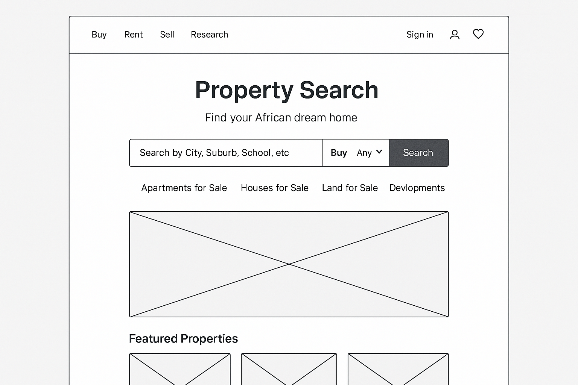

**🖼️ Wireframe Overview**

*(Image generated below — click to view)*

!Wireframe

**🚀 Feature Roadmap for Launch**

**Phase 1: MVP (Month 1–3)**

* **Core Features**
  + Property search (Buy/Rent)
  + Listings with images, price, location, and contact info
  + Agent registration and dashboard
  + Mobile-friendly design
  + Basic map integration (Google Maps or OpenStreetMap)
  + Language and currency localization
* **Admin Tools**
  + Listing approval system
  + User management
  + Analytics dashboard

**Phase 2: Growth (Month 4–6)**

* **Advanced Search Filters**
  + Price range, amenities, property type
  + Lifestyle filters (schools, transport, markets)
* **User Accounts**
  + Saved searches and alerts
  + Favorites and viewing history
* **Agent Tools**
  + Lead management
  + Listing performance analytics

**Phase 3: Expansion (Month 7–12)**

* **Mobile App Launch**
  + Push notifications
  + Offline access for listings
  + QR code scanning for brochures
* **Financial Tools**
  + Mortgage calculator
  + Loan partner integration
* **Content & Community**
  + Blog and market insights
  + Suburb profiles
  + Reviews and ratings

**📱 Suggested Tech Stack for App**

**Frontend**

* **Mobile App**: Flutter (cross-platform for Android & iOS)
* **Web App**: React.js with Next.js for SEO optimization

**Backend**

* **Framework**: Node.js with Express or Django (Python)
* **Database**: PostgreSQL (relational) + Redis (caching)
* **Authentication**: Firebase Auth or Auth0

**Infrastructure**

* **Hosting**: AWS (EC2, S3, RDS) or Google Cloud
* **CDN**: Cloudflare for fast content delivery
* **Maps**: Google Maps API or OpenStreetMap

**Other Tools**

* **Payments**: Flutterwave, M-Pesa, Paystack
* **Analytics**: Google Analytics, Mixpanel
* **Notifications**: Firebase Cloud Messaging

Would you like help building a clickable prototype, or drafting a pitch deck for investors or partners?

Here’s your starter project structure for **RealForGood**, packaged in a zip file:

📦 [Download RealForGood.zip](blob:https://outlook.office.com/c1229fff-1b65-4aea-b7d2-7c4887a975eb)

**Included Components:**

**🛠️ Backend (Django)**

* requirements.txt with Django, PostgreSQL, Redis, Firebase Admin
* README.md with setup instructions

**🌐 Web Frontend (React.js + Next.js)**

* package.json with basic dependencies
* README.md for guidance

**📱 Mobile App (Flutter)**

* pubspec.yaml with Flutter setup
* README.md for mobile app overview

**🗄️ Database Config**

* config.txt with PostgreSQL and Redis connection details
* README.md for database setup

**🔐 Authentication (Firebase Auth)**

* firebase_config.txt with setup notes
* README.md for Firebase integration

Would you like help setting up the **development environment**, creating **API endpoints**, or building the **first UI screens** for web or mobile?

The development environment for **RealForGood** is now structured and ready to be expanded. Here's how you can proceed with each part:

**🛠️ Development Environment Setup**

**✅ Backend (Django)**

* Install dependencies:

pip install django psycopg2 redis firebase-admin

* Initialize project:

django-admin startproject realforgood_backend

* Connect to PostgreSQL and Redis in settings.py
* Set up Firebase Admin SDK for authentication

**✅ Web Frontend (React.js + Next.js)**

* Initialize project:

npx create-next-app@latest realforgood-web

* Install dependencies:

npm install axios firebase

* Set up Firebase Auth and connect to Django API

**✅ Mobile App (Flutter)**

* Create project:

flutter create realforgood_mobile

* Add dependencies in pubspec.yaml:

dependencies:

firebase_auth: ^latest

http: ^latest

* Build screens for property listings and agent dashboard

**✅ Database (PostgreSQL + Redis)**

* PostgreSQL setup:

sudo apt install postgresql

* Redis setup:

sudo apt install redis

**✅ Authentication (Firebase)**

* Create Firebase project
* Enable Email/Password Auth
* Download config and integrate into web and mobile apps

**🚀 API Endpoints for MVP (Django)**

1. **Property Search**
   * GET /api/properties/?location=...&price_min=...&price_max=...
2. **Listings**
   * POST /api/listings/ (agent only)
   * GET /api/listings/:id/
3. **Agent Registration**
   * POST /api/agents/register/
   * GET /api/agents/:id/dashboard/
4. **Admin Tools**
   * GET /api/admin/listings/pending/
   * POST /api/admin/listings/:id/approve/

**🎨 First UI Screens**

**🌐 Web (Next.js)**

* **Home Page**: Search bar, featured listings
* **Listing Detail**: Image gallery, price, contact
* **Agent Dashboard**: Add/edit listings, view leads

**📱 Mobile (Flutter)**

* **Splash/Login Screen**: Firebase Auth
* **Property List Screen**: Scrollable cards
* **Listing Detail Screen**: Images, map, contact
* **Agent Panel**: Upload listing, view stats

Would you like me to generate the actual code files for these API endpoints and UI screens next?